# VISVESVARAYATECHNOLOGICALUNIVERSITY

## BELAGAVI,KARNATAKA-590014



**Seminar Report on**

“SOCIAL CONNECT AND RESPONSIBILITY”

*A Seminar report submitted to Visvesvaraya Technological University in partial fulfillment of requirements for the award of the Degree*

##### BACHELOR OF ENGINEERING

In

##### COMPUTER SCIENCE AND ENGINEERING

**SubmittedBy**

**SOUMYA. M. GALABHI**

**USN-4PM23CS106**

Under the guidance of

Mr.Shivanand C Maradi

#### Assistant Professor

Dept. Of CSE PESITM Shivamogga

  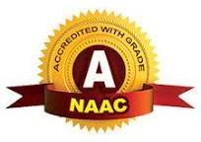

**Prerana Educational and Social Trust (R.)**

### PES INSTITUTE OF TECHNOLOGY AND MANAGEMENT

**NH-206, Sagar Road, Shivamogga-577204, Karnataka, India.**

**Affiliated** **to VTU, Belagavi, Approved by AICTE, New Delhi, Recognised by Govt. of Karnataka Accredited NBA(ECE,CSE,ME,ISE,&CV) and NAAC A**

**2024-2025**



***Certificate***

This is to certify that **TRISHA V.B**earing USN **4PM23CS116,**

**III** semester B.E. in Computer Science and Engineering has presented and has successfully completed the seminar on “**SOCIAL CONNECT AND RESPONSIBILITY**” in the partial fulfillment of the award of B.E. Degree VTU, Belgavi, for the academic year 2024-25.

##### COURSE COORDINATOR HOD

Mr. Shivanand C Maradi Dr. Arjun U

Assistant Professor Professor & HOD



# ACKNOWLEDGMENT

I would like to express my deep gratitude and respect to SCR Course Coordinator

**Mr. Shivanand C Maradi**, Assistant Professor, Department of Computer Science and Engineering, PESITM, Shivamogga his valuable guidance, supervision, encouragement and supporting me while doing this SCR Activity successfully.

I express my sincere thanks to **Dr. Arjun U** Head of the Department, Department of Department of Computer Science and Engineering, PESITM, Shivamogga for valuable guidance, supervision, encoragement and supporting me while doing this SCR Activity successfully.

We are highly grateful to **Dr. YUVARAJU B N** , Principal, PESITM, Shivamogga for advice and suggestions at various stages of the work.

I also extend our thanks to the Management of PES Institute of Technology & Management for having provided good laboratory and library facilities. We remain grateful to the co- operation and the help rendered by the teaching and non-teaching staff of the department.

**TRISHA VISHWANATH BALI**

##### USN-4PM23CS116



|  |  |
| --- | --- |
| **TABLE OF CONTENTS** |  |
| **1. Certificate………………………………………………...........................** |  |
| **2. Acknowledgement…………………………………………………………**  **3. Table of Contents………………………………………………………….** |  |
| **Sl.No. MODULES CONTENTS** | **PAGE NO.** |
| **1. MODULE-1 Plantation and adoption of a tree** | **6-10** |
| **2. MODULE-2 Heritage walk and crafts corner** | **11-19** |
| **3. MODULE-3 Organic farming and waste management** | **20-26** |
| **4. MODULE-4 Water Conservation** | **27-30** |
| **5. MODULE-5 Food Walk** | **31-36** |
|  |  |
|  |  |

**ACTIVITY 1: Plantation and Adaptation of Tree**

**Plant name: Peace Lilly**

**Necessary of planting trees:**

Tree planting is widely acknowledged as a meaningful and eco-friendly activity that individuals can engage in to support the planet, especially when carried out correctly. Trees offer a variety of long-term and short-term advantages: they enhance the landscape, absorb and store carbon dioxide from the atmosphere, mitigate heavy rainfall to lower flood risks, improve air quality, and help combat the urban heat island effect by providing shade and reflecting sunlight. We commemorate Plantation Day on March 21st each year.

**Deforestation:**

Deforestation, also known as forest clearance, refers to the removal of trees and forests from land, which is then repurposed for non-forest uses such as agriculture, ranching, or urban development. The most significant deforestation occurs in tropical rainforests. Currently, forests cover about 31% of the Earth's land surface, which is one-third less than before agricultural expansion, with half of that loss occurring in the last century. Each year, between 15 to 18 million hectares of forest—an area equivalent to Bangladesh—are lost, resulting in an average of 2,400 trees being cut down every minute.

The consequences of deforestation include climate change, desertification, soil erosion, reduced crop yields, flooding, increased greenhouse gas emissions, and various challenges for Indigenous communities. To address the issue of deforestation, one effective approach is through reforestation efforts.

PEACE LILLY

Scientific name: Spathiphyllum wallisii

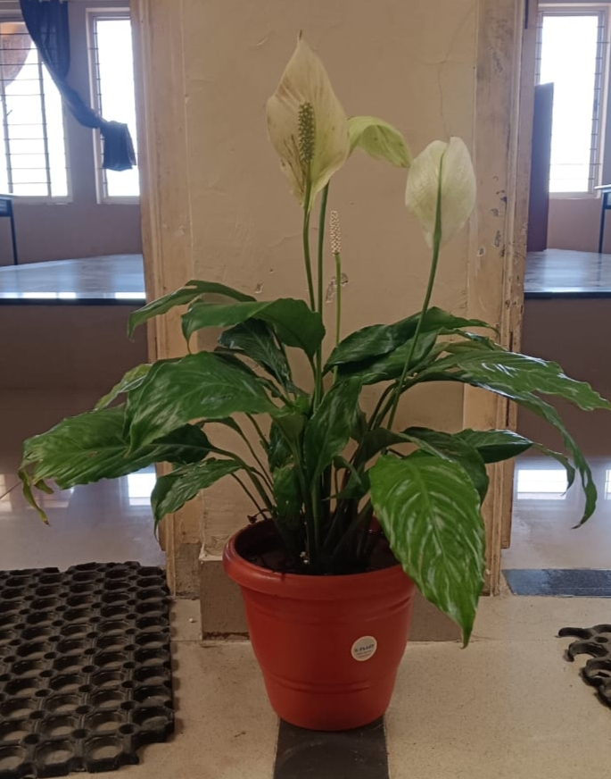

Fig.1.1. Plantation

Spathiphyllum wallisii, commonly known as the Peace Lily, is a popular houseplant renowned for its attractive white flowers and air-purifying properties. Here's some detailed information about this plant:

*Botanical Classification*

Family: Araceae

Genus: Spathiphyllum

Species: wallisii

Common Name: Peace Lily, White Sails

*Physical Characteristics*

Leaves: The plant has glossy, dark green leaves that grow in a rosette pattern. The leaves are lance-shaped and can grow up to 12 inches (30 cm) in length.

Flowers: The Peace Lily is known for its distinctive white spathes (modified leaves) that surround a spadix (a central spike with tiny flowers). These flowers bloom typically in late spring to early summer and may last for several weeks.

Size: It is a medium-sized plant, typically growing to a height of about 18–24 inches (45–60 cm) tall, though some varieties can reach slightly higher.

Care Requirements

Light: Peace Lilies thrive in bright, indirect light but can also tolerate low light conditions. However, they may not bloom as well in low light.

Watering: They prefer consistently moist soil, but not soggy. It's best to water the plant when the top 1–2 inches of soil feels dry. Overwatering can lead to root rot.

Temperature: Ideal temperatures for Spathiphyllum wallisii range from 65°F to 80°F (18°C to 27°C). They should be kept away from cold drafts or temperatures below 50°F (10°C).

Humidity: They prefer high humidity, which is why they thrive in bathrooms or kitchens. Regular misting can help, especially in dry indoor environments.

Soil: A well-draining potting mix, such as one designed for houseplants, is best for Peace Lilies. It should retain some moisture but not stay waterlogged.Top of Form

Fertilization: Feed the plant with a balanced, water-soluble fertilizer about once a month during the growing season (spring and summer). Reduce feeding in the fall and winter when the plant is dormant.

*Health Benefits*

Air Purification: Peace Lilies are known for their ability to improve indoor air quality by filtering out harmful toxins like ammonia, benzene, and formaldehyde.

Non-Toxic: While the plant is often recommended for homes, it's worth noting that it is mildly toxic to pets, especially cats and dogs, if ingested. The plant contains calcium oxalate crystals that can cause oral irritation and digestive issues.

Propagation

Division: The most common method of propagating Spathiphyllum wallisii is by dividing the plant. This is typically done when repotting. The rhizomes can be split into smaller sections, each with roots and a few leaves, and planted in separate pots.

*Common Problems*

Yellowing Leaves: This can be a sign of overwatering, underwatering, or low light conditions.

Brown Tips: Dry, brown tips on leaves can occur due to low humidity or over-fertilizing.

Pests: While relatively pest-resistant, they can occasionally be affected by aphids, mealybugs, or spider mites, especially in dry indoor conditions.

Additional Notes

Flowering: Peace Lilies often bloom in the warmer months, though in low-light conditions, they might not flower. Occasionally, even mature plants can go without blooms for extended periods.

Longevity: With proper care, Spathiphyllum wallisii can live for many years, adding beauty and freshness to any indoor space.

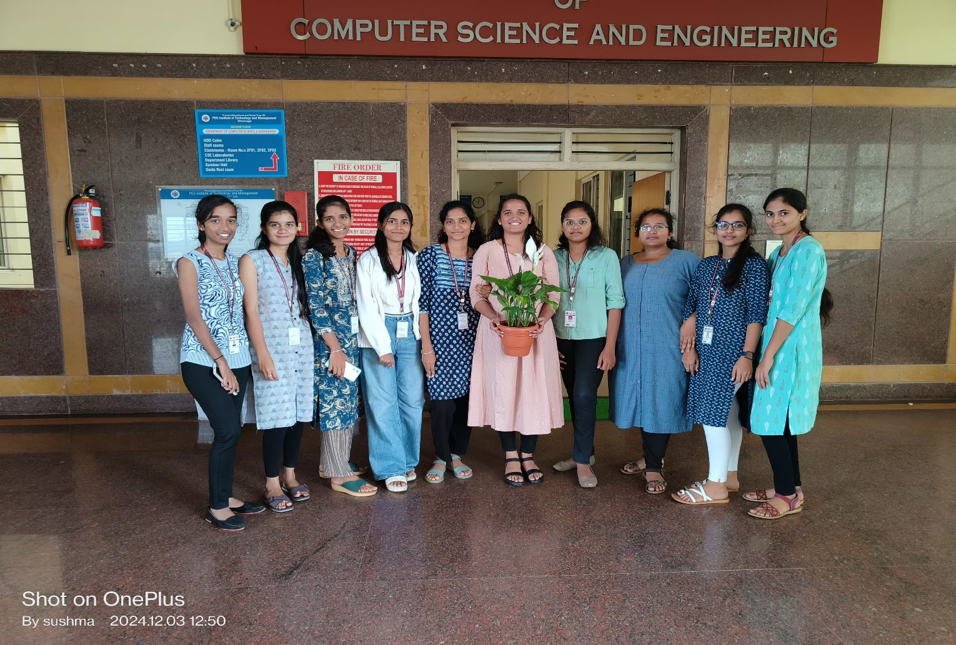This versatile, elegant plant is ideal for people seeking a low-maintenance, attractive addition to their home or office decor.

Bottom of Form

Fig.1.1 Adoption of a tree

ACTIVITY 2: Heritage walk

**Places name: Sringeri, Kuppalli, Hariharapura Temple**

**Exploring Sringeri, Kuppalli, Hariharapura Temple:**

This heritage walk covers some of the city's most iconic sites: Sringeri sharadamba temple, Kavi mane – Kuppalli and Sri laxmi Narasimha temple of Hariharapura.

**Sringeri:**

**The Sringeri Sharada Peetha or Matha is located South of the Sri Sharadamba temple, across the Tunga river, in Narasimha Vana. A foot bridge, called Vidyatheertha Setu connects the two sides. The Sringeri Sharada Peetha, also called Dakshinamnaya Sringeri Sharada peetam, is one of the four Hindu Advaita maths established by Sri Adi Shankara. Following the tradition initiated by Adi Shankara, the maţha is in charge of the Yajur Veda (the Krishna (Black) Yajurveda is more prevalent in South India, over which the maţha has authority in the Smarta tradition). The head of the matha is called Jagadguru (teacher to the world) and also carries the Shankaracharya name as a title.**

**Sringeri is a major pilgrimage site for Hindus, attracting devotees from across India. The town is known for its religious activities, including regular rituals, festivals, and cultural programs that promote spiritual growth and community participation.**

**Sringeri is a harmonious blend of spirituality, history, and natural beauty. Visiting this town provides an enriching experience that nurtures the soul and mind. Whether you're seeking spiritual solace, cultural enrichment, or simply a peaceful retreat, Sringeri offers it all.**

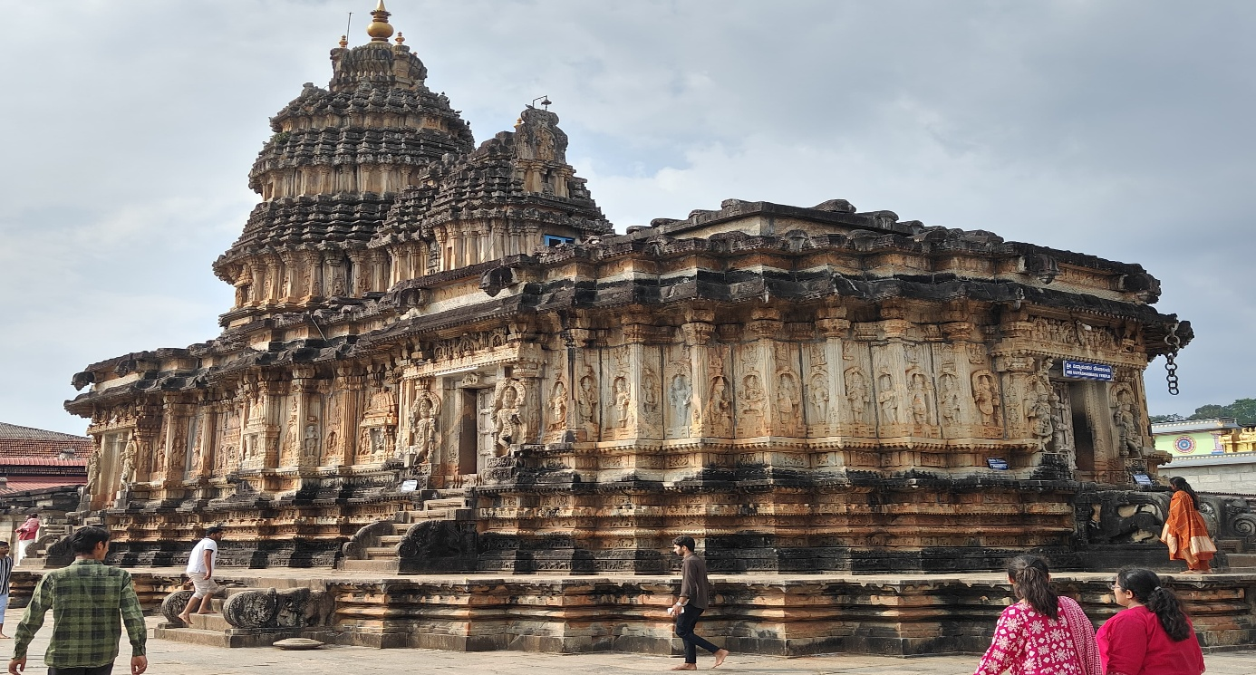

Fig.2.1. Heritage walk and crafts corner

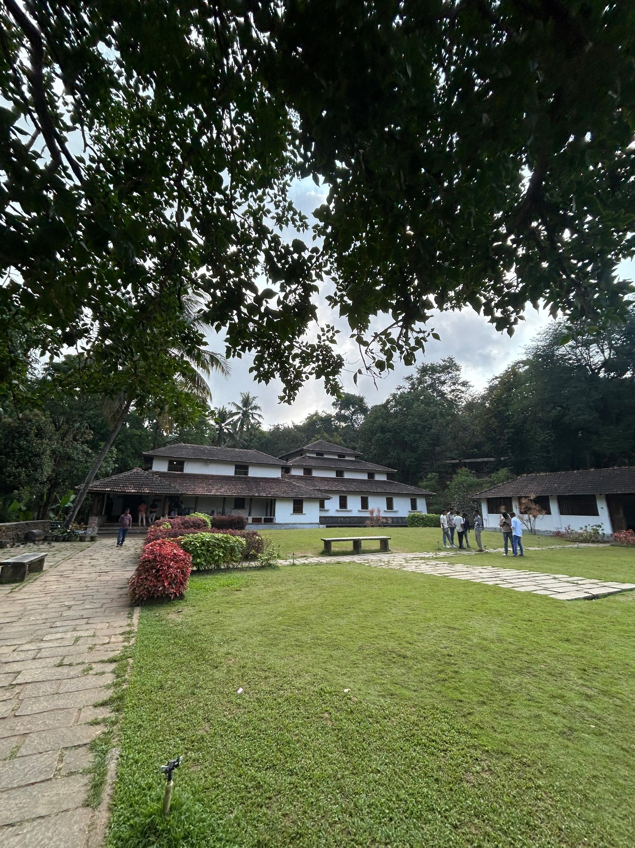

Fig.2.2Heritage walk and crafts corner

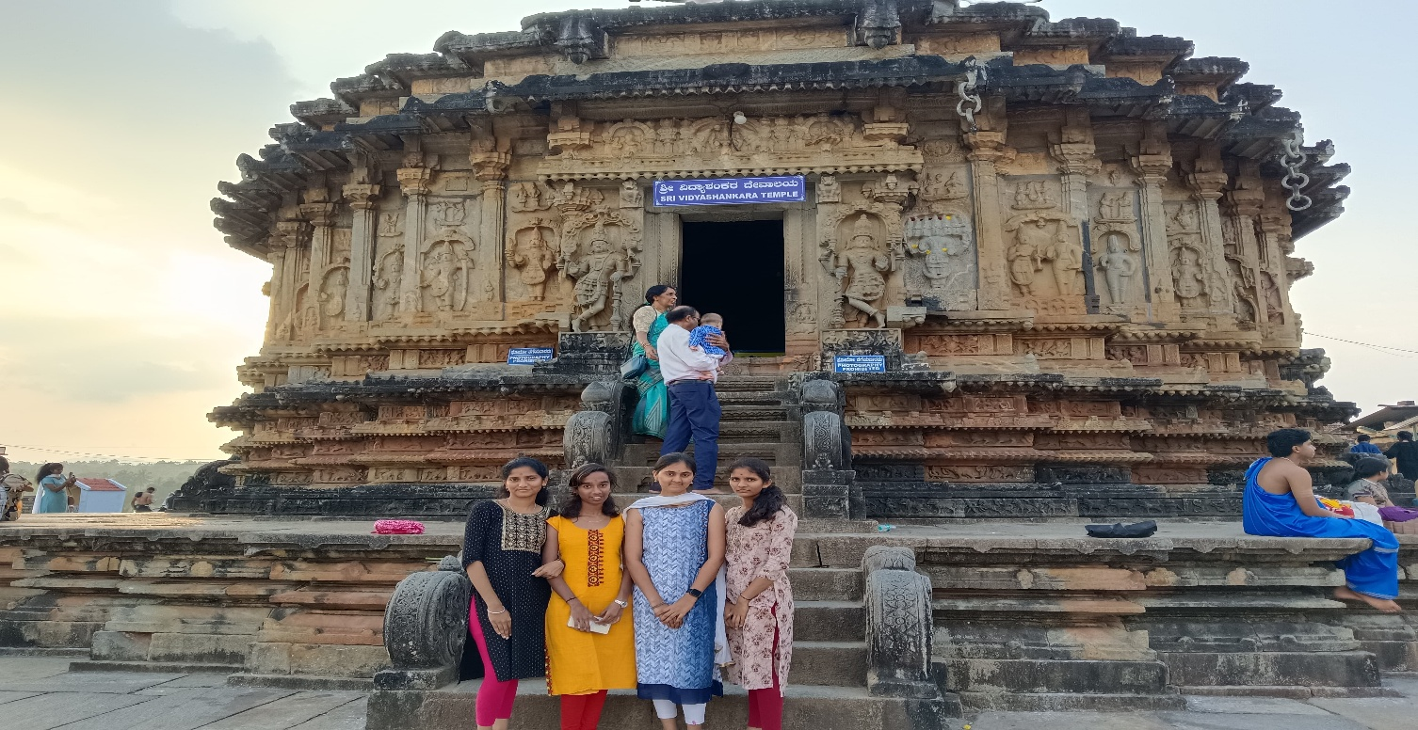

Fig.2.3. Heritage walk and crafts corner

**Although there are numerous temples at Sringeri, one of the architectural marvels at Sringeri is the Vidyashankara Temple, constructed by the Vijayanagara Empire rulers. This temple pays homage to Vidyatirtha, one of the pontiffs of the Sringeri temple. With its intricate carvings and magnificent Dravidian-style architecture, the Vidyashankara Temple is a visual delight and a spiritual haven, making it one of the most famous temples in India.**

**Kuppalli:**

**Kuppalli, also known as Kuppali, is a small village in Thirthahalli taluk of Shimoga district in the state of Karnataka in India. It is famous for being the childhood home of the renowned Kannada poet Kuvempu.** **he celebrated Kannada poet and writer Kuvempu belonged to this village and was very attached to it. Indeed, this pen-name Kuvempu pays homage to the author's home, created as it is from the first letters from his full name "Kuppali Venkatappa Puttappa". Kuppalli is also the birthplace of Poornachandra Tejaswi, the son of Kuvempu and a famous Kannada writer himself. It is also the place where Kuvempu and Poornachandra Tejaswi have been cremated.**



Fig.2.41. Heritage walk and crafts corner

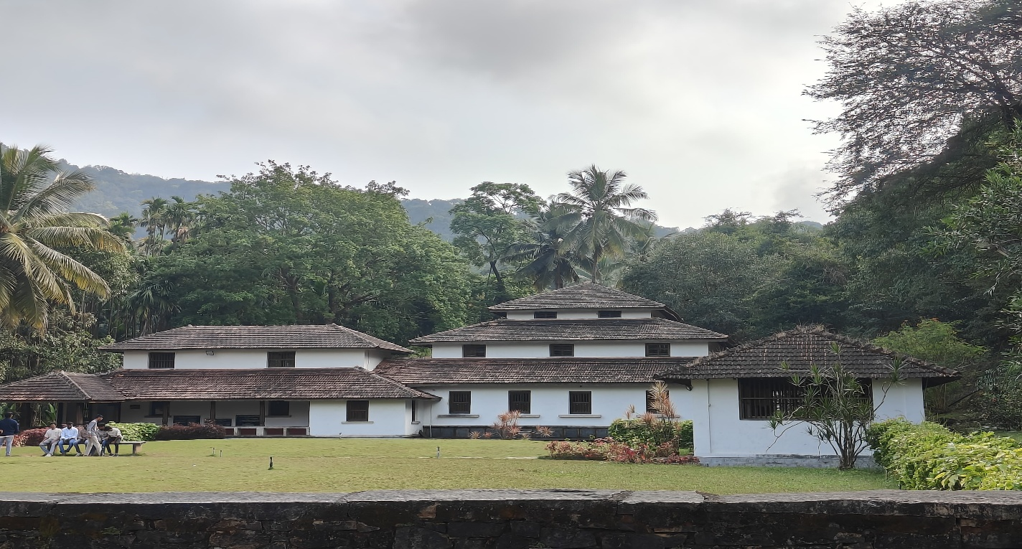

Fig.2.5. Heritage walk and crafts corner

**Hariharapura Temple:**

The river Thunga flowing at Hariharapura is called Uttaravahini. The Kshetras where rivers flow as Uttaravahini are regarded great Siddha Kshetras, where performing any kind of worship or spiritual Sadhana yields manifold benefits.

Hariharapura is one such powerful Siddha Kshetra discussed in high praise by various religious texts and Puranas. Vedic Seers refer this Kshetra as a very effective pilgrimage that is capable of warding off all sins and granting both spiritual & material upliftment. situated at the banks of River Thunga, is a Kshetra highly extolled by Vedic literatures. It is located at a distance of about 10 Kms from Koppa Taluk and 20 Kms from the famous pilgrim center of Sringeri, in the Western Ghats.

**It is a place replete with rich natural splendor, enveloped in deep serenity and divine presence. The reverberating Vedic chants amidst lush greenery and the gentle flow of River Tunga creates an exquisite ambience of divine fervor and becomes an ideal retreat for the human mind constantly stressed under stormy thoughts and emotions.**

**Sri Sharada Parameshwari, the main goddess of this Dharmapeetam. Sri Jagadguru Shankaracharya consecrated Srichakra Yantra and Sri Sharada Parameshwari Idol was installed and thus Sri Sharada Lakshminarasimha Peetam at Divyakshetra Hariharapura.**

**On the outer wall of the Sri Sharada Parameshwari temple at Divya Kshetra Hariharapura “Vashini Vaagdevata” idols are installed. It is believed praying to the Goddess Sri Sharada Parameshwari, the devotee will be blessed with “Brahma Jnanam”.**

**Lord Sri Lakshminarasimha Swamy and Mother Sri Sharada Parameshwari are the chief deities of this Dharmapeetam. This ancient Dharmapeetam boasts of unbroken illustrious legacy of Jagadgurus, since from the time of Sri AdiShankaracharya.**



Fig.2.6. Heritage walk and crafts corner



Fig.2.7. Heritage walk and crafts corner

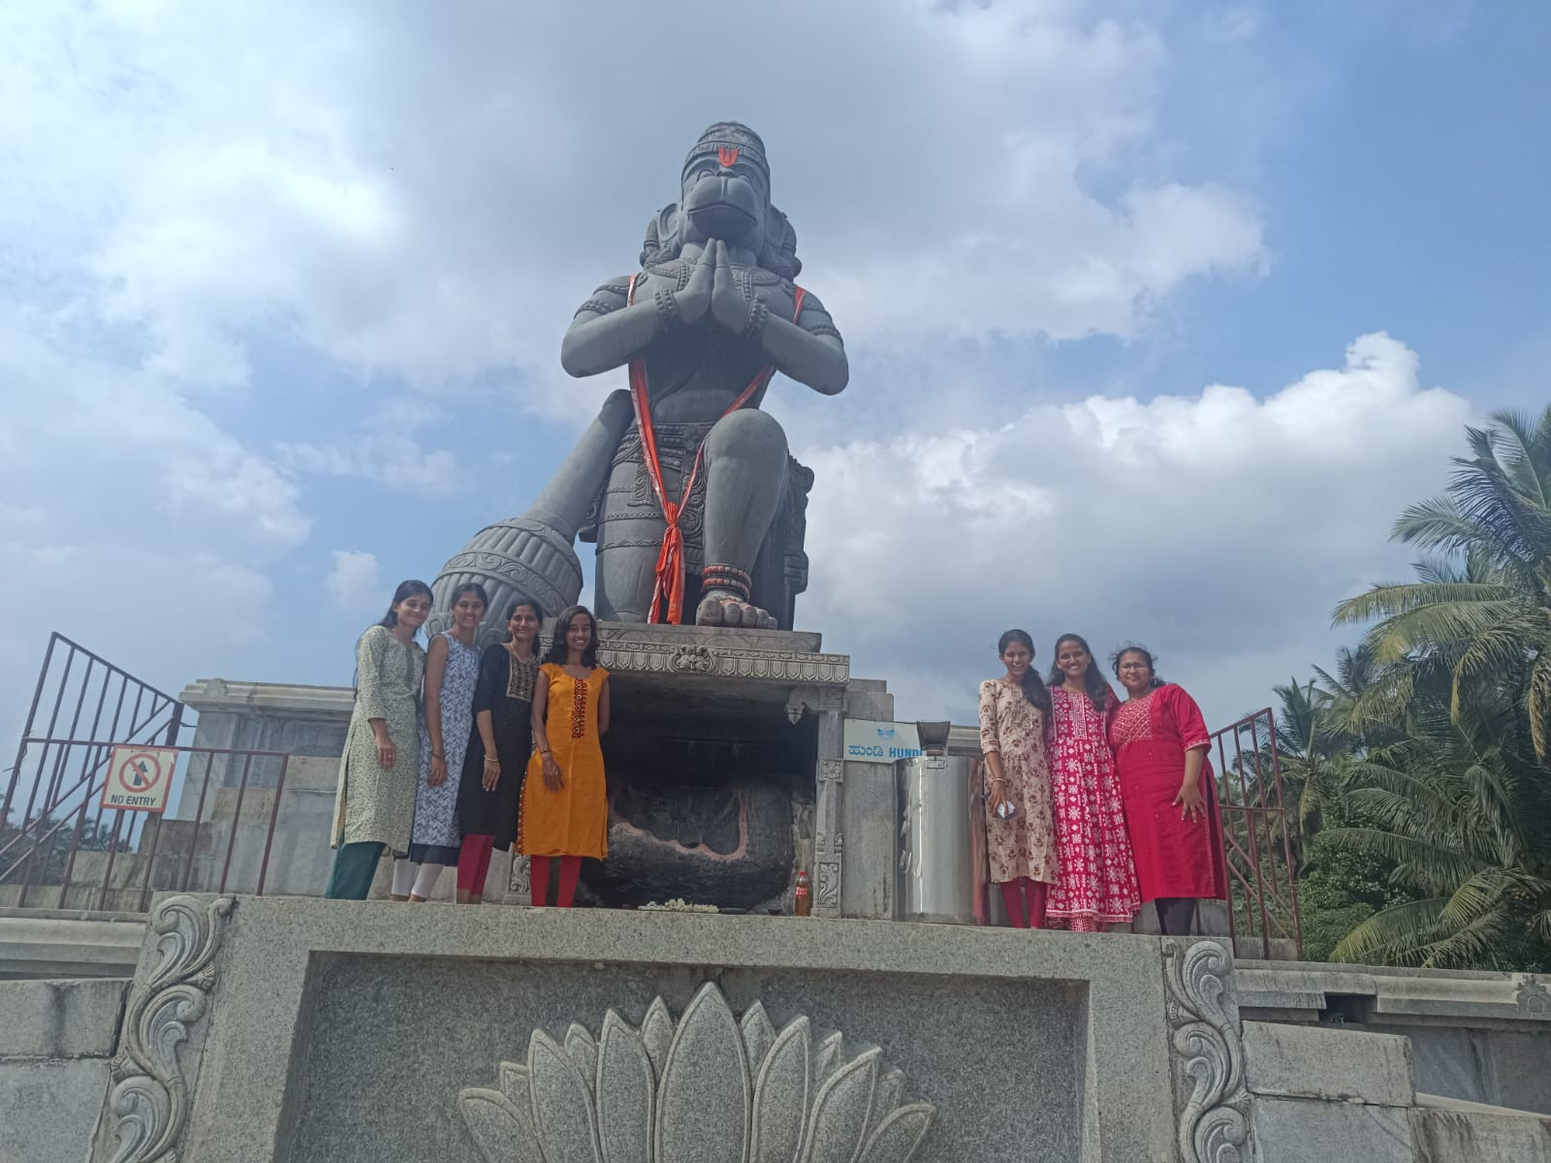

Fig.2.8. Heritage walk and crafts corner

ACTIVITY 3: Organic Farming and Waste Management

“Sustainable Practices for a Better Future”

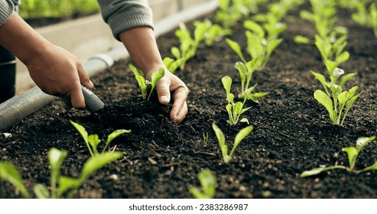Organic Farming:

Fig.3.1. Organic farming and waste management

Introduction:

**Organic farming and waste management are two interconnected practices that play critical roles in  sustainable agriculture and environmental conservation. Organic farming emphasizes the use of natural  methods to cultivate crops and raise livestock without the use of synthetic fertilizers, pesticides, or  genetically modified organisms. On the other hand, waste management focuses on minimizing, reusing,  recycling, and properly disposing of waste generated from agricultural activities to reduce environmental  pollution and promote resource conservation.**

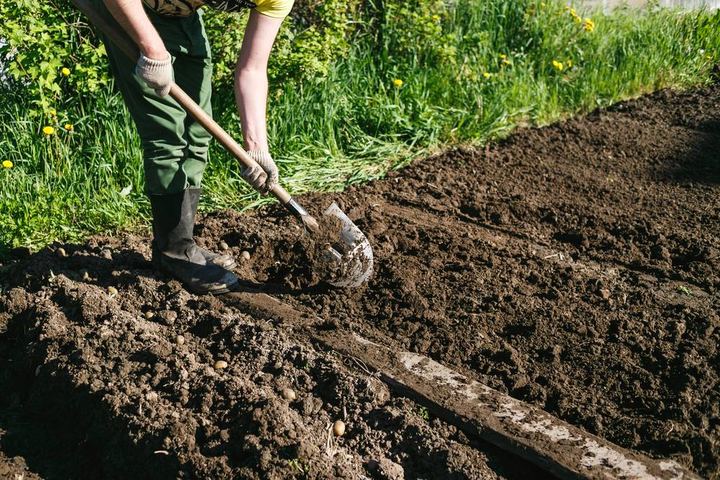

Fig.3.2. Organic farming and waste management

**Organic farming promotes biodiversity, soil health, and long-term sustainability by employing techniques  such as crop rotation, composting, biological pest control, and cover cropping. These methods enhance  soil fertility, reduce erosion, conserve water, and minimize the negative impact on ecosystems compared  to conventional farming practices.**

**Waste management in organic farming encompasses various strategies to manage organic waste, including  crop residues, animal manure, and food scraps. Composting is a common practice in organic agriculture,  where organic waste materials are decomposed into nutrient-rich compost, which can be used to fertilize  soil and improve its structure and moisture.**

**Importance of Organic Farming:**

**Health Benefits**

**Chemical-Free Food: Organic farming avoids the use of synthetic pesticides and fertilizers, resulting in food that is free from harmful chemicals. This is beneficial for consumers' health, reducing the risk of exposure to toxic substances.**

**Nutrient-Rich Produce: Studies have shown that organically grown crops often contain higher levels of essential nutrients like vitamins, minerals, and antioxidants compared to conventionally grown crops.**

**Waste management:-** **Sustainable Practices for a Greener Future**

**Introduction:-**

**Waste management is the process of handling waste materials from their inception to their final disposal. This includes collection, transportation, processing, recycling, and disposal.**

**Aim: To minimize the environmental impact and improve public health by managing waste efficiently.**

**Over the past few years, waste management has become a global concern. Commonly, waste is generated in households, factories, construction sites, refineries and nuclear power plants. As the population is increasing, consumption trends are changing. Along with the improvement in lifestyle, it has posed alarming threats to the environment. If waste is not managed wholistically it can cause serious problems to human health and the environment. So, it is necessary for people and businesses to know the importance of waste management.**

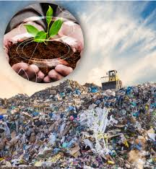

Fig.3.3. Organic farming and waste management

**The handling and disposing of liquid and solid waste, its treatment, and recycling for further use falls under waste management.**

**Centuries ago, people used to dispose of their waste by digging a hole into a far-off land area. This waste disposal technique was meant to be efficient because of less population around that time. Waste production was less due to low population which made waste management easy.**

**But now, due to the growing number of people, waste production has drastically increased making disposal difficult. The waste produced nowadays includes non-biodegradable and inorganic elements.**

**If this waste is disposed of in landfills, it will decompose unnaturally and will take a lot of time. Waste management allows users to efficiently and properly dispose of all kinds of waste.**

**Importance of Waste Management**

* **The indiscriminate burning of various types of waste, a common practice, is detrimental to the environment. This form of improper waste disposal leads to air contamination and the release of pollutants, contributing to the alarming climate changes our planet is currently grappling with.**
* **Wastes, when mishandled, emit greenhouse gasses into the atmosphere, which can result in severe weather events like storms and typhoons, as well as persistent, sweltering heat patterns.**
* **Moreover, improper waste management practices can result in contamination of the air, water, and soil, posing harm to both the environment and human health.**
* **To mitigate these adverse effects and preserve the environment, it is imperative to adopt effective waste management techniques, including the proper disposal of waste in designated garbage dustbins.**

**Importance Of Waste Management In Terms Of Animal And Marine Life**

* **Improper waste management doesn't just affect humans and the environment; it also has dire consequences for animals and marine life.**
* **Animals, much like humans, are vulnerable to the pollution resulting from inadequate waste management practices. For example, toxic substances seeping into the soil can lead to the death of animals that graze in areas close to hazardous sites, such as landfills.**
* **Furthermore, marine animals face a significant threat when they ingest floating materials like Styrofoam and cigarette butts, which can lead to fatal outcomes.**
* **The repercussions extend to humans who rely on marine life for sustenance and livelihoods, making it imperative to adopt effective waste management methods as a means of preserving wildlife, especially marine ecosystems.**

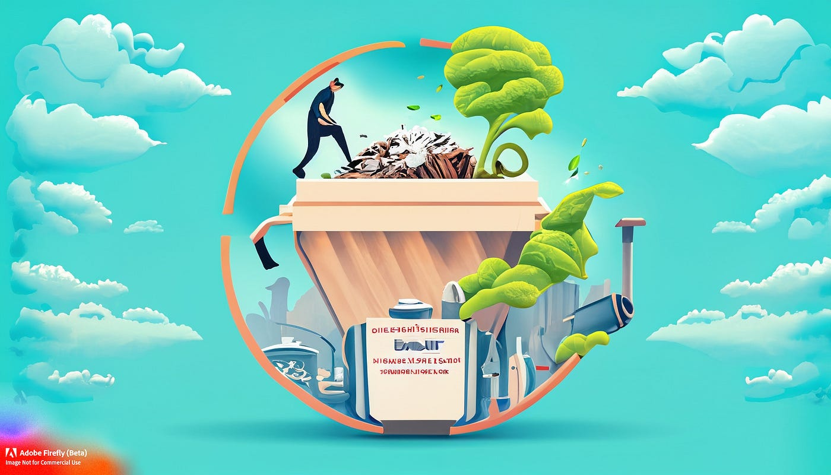

Fig.3.4. Organic farming and waste management

**Waste Management Strategies :-**

* **Waste prevention: Reducing waste at the source to prevent it from being generated**
* **Waste minimization: Reducing the amount of waste that is generated**
* **Recycling: Processing materials like glass, plastic, paper, and metal into new products**
* **Composting: Turning organic waste like food and yard waste into compost that can be used as fertilizer**
* **Incineration: Destroying hazardous waste, medical waste, and municipal solid waste to generate electricity and reduce waste volume**
* **Landfill disposal: A final option for waste disposal**
* **Biological treatment: A waste management strategy**
* **Waste-to-energy conversion: A technology that uses waste to generate energy**

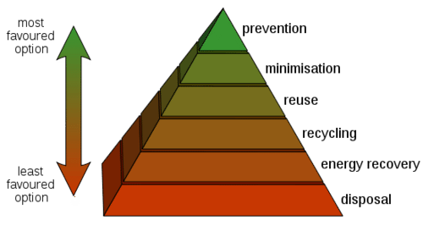

Fig.3.5. Organic farming and waste management

ACTIVITY 4: Water Conservation

“ Preserving Our Most Precious Resource”

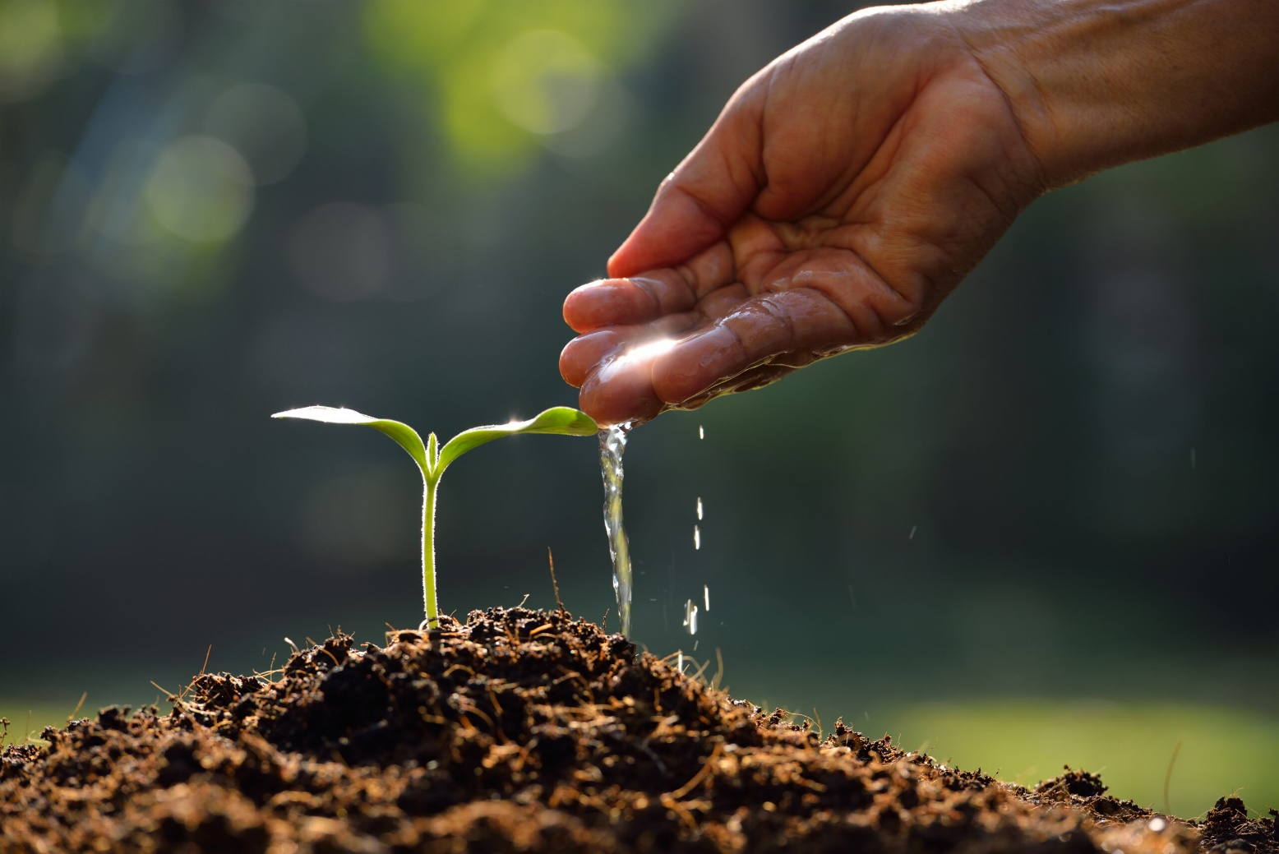

Fig.4.1. Water Conservation

**Water conservation is a critical practice that addresses the growing concern of water scarcity and environmental sustainability. With global populations increasing and climate change impactingweather patterns, ensuring the availability of clean and reliable water resources has become more challenging than ever. Water conservation involves the mindful and responsible use of water resources to minimize waste, preserve ecosystems, and meet the needs of both present and future generations.**

**From reducing domestic consumption to implementing efficient agricultural irrigation techniques, water conservation efforts play a vital role in safeguarding freshwater ecosystems, supporting biodiversity, and mitigating the impacts of droughts and water shortages. In this essay, we will explore the importance of water conservation, its benefits, and various strategies that individuals, communities, and governments can adopt to conserve this precious resource.**

**Water conservation offers numerous benefits, both environmental and economic. By using water more efficiently, we can reduce pressure on freshwater ecosystems, protect aquatic habitats, and maintain water quality. Conserving water also lowers energy consumption associated with water treatment and distribution, leading to cost savings and reduced greenhouse gas emissions.**

**NEED FOR WATER CONSERVATION:-**

**The need for water conservation arises from a combination of factors that collectively threaten the availability and quality of freshwater resources. One of the most pressing concerns is the increasing demand for water due to population growth, urbanization, and industrialization. As more people inhabit urban areas and economies develop, the demand for water for domestic, agricultural, and industrial purposes escalates, placing strain on already limited water supplies.**



Fig.4.2. Water Conservation

**Additionally, climate change exacerbates water-related challenges by altering precipitation patterns, leading to more frequent and severe droughts in some regions and intense rainfall events in others. These shifts in weather patterns disrupt water availability and exacerbate water scarcity in vulnerable areas, further stressing ecosystems and communities reliant on freshwater resources. Furthermore, inefficient water uses and management practices contribute to wastage and depletion of water resources. From leaky pipes and inefficient irrigation systems to excessive water consumption in households and industries, inefficient water use exacerbates water scarcity and undermines efforts to sustainably manage water resources.**

**Moreover, water pollution poses a significant threat to freshwater ecosystems and human health.**

**Contamination from agricultural runoff, industrial discharges, and untreated sewage not only degrades water quality but also reduces the availability of clean water for drinking, sanitation, and irrigation. Given these challenges, water conservation is imperative to ensure the sustainablemanagement of freshwater resources.**

**By implementing measures to reduce water wastage, improve efficiency, and protectwater quality, we can mitigate the impacts of water scarcity, support ecosystems, and safeguard the health andwell-being of communities around the world.**

**In conclusion, the need for water conservation is driven by increasing demand, climate change, inefficient water use, and pollution. By prioritizing water conservation efforts, we can address these challenges and ensure the availability of clean and reliable water for current and future generations.**

**The need for water conservation has become increasingly urgent in the face of growing challenges related to water scarcity, population growth, and climate change.**

**EXISTING WASTE MANAGEMENT SYSTEM IN OUR COLLEGE CAMPUS:-**

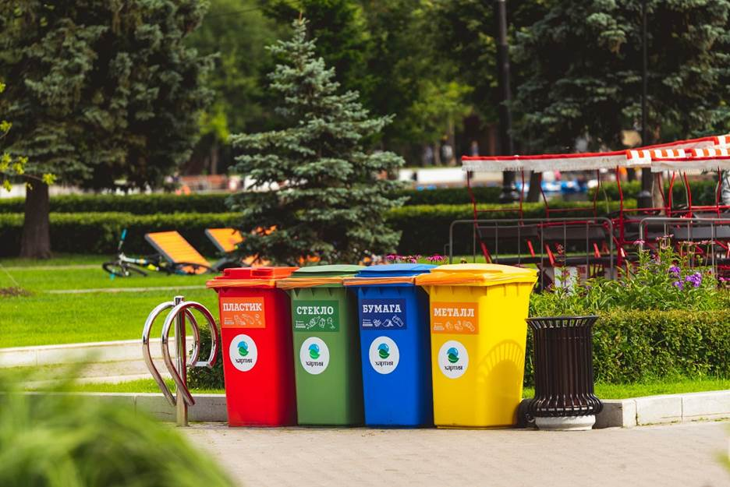

Fig.4.3. waste management

**Solid waste management:**

**❖ Waste is collected on a daily basis from various sources and is separated as dry and wet waste.**

**❖ Color coded dustbins are used for different types of wastes. Green for wet and blue for solid**

**waste.**

**❖ Daily garbage is collected by housekeeping personal.**

**Liquid Waste Management:**

**❖ The waste chemicals mixed water from laboratory passes through concealed pipe line into**

**soak pit & recycled water is used for the watering trees or non-potable usage.**

**❖ Liquids are diluted by getting mixed with the washroom and toilet liquid wastes in to the**

**common drainage.**

**Biomedical waste management:**

**❖ Biomedical generated from the laboratory gets handover to authorized waste personnel.**

**E-waste management:**

**❖ The E-waste collected is stored in store room and disposed every year accordingly.**

**❖ Old monitors and CPUs are repaired by our technician and reused.**

**CONCLUSION:-**

**From completing this activity, we can conclude that Organic Farming is far better than conventional**

**farming because it replenishes natural ecosystems and maintain the balance by keeping water and air**

**cleaner, all without toxic pesticide residues.**

**As for the waste management, our first goal must be to educate the people about the importance of keeping the environment clean must be their main goal only then we can slow and steadily bring the changes we desire.**

**Waste management in India for cities and villages are quite different, so they must be solved using different approach.**

**As a student our responsibility is to create awareness of the clean environment so that people will value the Nature and lead a healthy lifestyle.**

ACTIVITY 5: Heritage walk

**“Exploring Culinary Delights”**



##### Fig.5.1. Food Walk

**Hyderabadi biryani, a culinary masterpiece renowned for its aromatic flavors and exquisite blend of spices, holds a special place in the heart of Indian cuisine. Originating from the city of Hyderabad, located in the southern state of Telangana, this iconic dish is a testament to the rich culinary heritage and cultural diversity of the region.**

**Hyderabadi biryani is characterized by its unique cooking technique, which**

**involves layering fragrant basmati rice with marinated meat, onions, herbs, and spices, and slow-cooking the ingredients to perfection in a sealed pot or dum.**

**The result is a tantalizing fusion of flavors, where each grain of rice is infused with the essence of the spices and the tender, succulent meat. Whether enjoyed at lavish feasts or humble home kitchens, Hyderabadi biryani continues to captivate food enthusiasts around the world with its irresistible aroma, tantalizing taste, and rich culinary history.**

**Hyderabadi biryani is traditionally prepared using basmati rice, which is known for its long grains and delicate fragrance. The meat used in Hyderabadi biryani is typically either chicken, goat, or lamb, although variations with beef and seafood are also popular.**

**The meat is marinated in a flavorful mixture of yogurt, spices, and herbs, which may include saffron, cardamom, cloves, cinnamon, ginger, garlic, and mint.**

**Hyderabadi biryani, a culinary masterpiece renowned for its aromatic flavors and exquisite blend of spices, holds a special place in the heart of Indian cuisine.**

**Originating from the city of Hyderabad, located in the southern state of Telangana, this iconic dish is a testament to the rich culinary heritage and cultural diversity of the region.**

**CITY'S CULINARY PRACTICES**

**Hyderabadi biryani, a popular rice dish in India, has evolved over time due to changes in ingredients, cooking methods, and cultural influences.**

**Here are some differences between cooking Hyderabadi biryani in the past and present:**

**❖ Cooking utensils: In the past, Hyderabadi biryani was cooked in large, heavy-bottomed copper pots over wood-fired stoves, which required a lot of skill and experience. Nowadays, modern kitchen appliances like gas stoves, pressure cookers, and electric rice cookers are used to make the dish.**

**❖ Ingredients: The basic ingredients for Hyderabadi biryani have remained the same, which include long-grain Basmati rice, meat (usually chicken or lamb), spices, and herbs. However, in the past, ingredients were sourced locally, and the recipe varied depending on the availability of ingredients. Today, Hyderabadi biryani is prepared using a wider range of spices and ingredients from different parts of the world.**

**❖ Spice blends: Traditional Hyderabadi biryani used a blend of spices, which included whole and ground spices such as cinnamon, cardamom, cloves, bay leaves, and black pepper. Today, spice blends for biryani are readily available in grocery stores, and these blends may contain a variety of spices, including nutmeg, mace, and saffron.**

**❖ Cooking techniques: In the past, the meat was cooked separately and layered with rice, which was then sealed and cooked on low heat for several hours, allowing the flavours to meld together. Today, the meat is often cooked with the rice in a pressure cooker, reducing cooking time and simplifying the process.**

**❖ Serving style: Hyderabadi biryani was traditionally served on a large platter, with the meat and rice layered together, and garnished with fried onions and boiled eggs. Today, individual servings are more common, with the meat and rice served separately, and garnished with a variety of accompaniments, including raita (yogurt dip), chutney, and salad. Whether it's the spicy tangri kebabs sizzling on street corners or the decadent double ka Metha served at weddings, Hyderabad offers a culinary adventure like no other. Families gather around the dining table, friends share stories over plates of biryani, and vendors line the streets, serving up this beloved dish to hungry patrons.**



##### Fig.5.2. Food Walk

***Ingredients of Hyderabadi Biryani:***

**Hyderabadi biryani is a popular dish from the city of Hyderabad in India. The dish is made using a combination of spices, meat (usually chicken or lamb), and basmati rice. While I cannot give a comprehensive list of all the ingredients used in Hyderabadi biryani, here are some common indigenous materials used in the dish:**

**Basmati Rice: Basmati rice is a long-grain, aromatic rice that is commonly used in Indian cuisine, including biryanis.**

**Meat: Hyderabadi biryani is typically made using chicken or lamb meat.**

**Spices: The dish is seasoned with a variety of spices, including cinnamon, cloves, cardamom, bay leaves, cumin, coriander, and black pepper.**

**Saffron: Saffron is a highly prized spice that is often used in biryanis for its unique flavor and bright**

**yellow color Yogurt: Yogurt is used in the marinade for the meat, which helps to tenderize it and infuse it with flavor.**

**Fried onions: Fried onions are used as a garnish on top of the biryani and add a sweet, caramelizedflavorto the dish.**

**Ghee: Ghee, or clarified butter, is used in the recipe to add richness and depth of flavor.**

**DESCRIPTION OF THE ACTIVITY**

**During the food walk, the guide provides information about the ingredients, preparation methods, and cultural significance of each dish, as well as interesting anecdotes and stories about the food and the people who make and eat it. Participants can also ask questions and engage in discussions with the guide and other group members.**

**Food walks are a fun and delicious way to explore a new city or neighborhood, meet new people, and learn about the local food culture. They are suitable for all ages and dietary preferences, and can be customized to accommodate specific needs and interests etention capacity**